**A PROJECT REPORT ON**

**Chatbot Based on Song Recommendation**

Submitted for fulfillment of award of the degree

**BACHELOR OF TECHNOLOGY**

**(Computer Science & Engineering)**

**BY**

Raashi Lokhande (MITU22BTCS0615)

Prachi Kunjir(MITU22BTCS0545)

Sayali Ingole(MITU22BTCS0755)

Sushaan Satyam(MITU22BTCS0880)

**Under the guidance of**

Prof. Suresh Kapre



**Department of Computer Science and Engineering MIT School of Computing**

**MIT Art, Design and Technology University, Pune MAEER’s**

**Rajbaug Campus, Loni-Kalbhor, Pune 412201 November, 2023**



**MIT SCHOOL OF COMPUTING**

DEPARTMENT OF COMPUTER SCIENCE & ENGINEERING MAEER’s

Rajbaug Campus, Loni-Kalbhor, Pune - 412201

**CERTIFICATE**

This is to certify that the project report entitled

**“Chatbot Based on Song Recommendation”**

Submitted by

Raashi Lokhande (MITU22BTCS0615)

Prachi Kunjir(MITU22BTCS0545)

Sayali Ingole(MITU22BTCS0755)

Sushaan Satyam(MITU22BTCS0880)

is a bonafide work carried out by students under the supervision of Prof Suresh Kapre and it is submitted towards the fulfillment of the requirement of MIT-ADT University, Pune for the award of the degree of Bachelor of Technology (Computer Science & Engineering)

(Prof. Suresh Kapre)

Prof. .Suresh Kapre Dr.Ganesh Pathak Project Coordinator Professor & HOD

Prof.Dr.Ramachandra Pujeri Dean

**DECLARATION**

We, the team members

**Name Enrollment No -**

Raashi Lokhande (MITU22BTCS0615)

Prachi Kunjir(MITU22BTCS0545)

Sayali Ingole(MITU22BTCS0755)

Sushaan Satyam(MITU22BTCS0880)

Hereby declare that the project work incorporated in the present project entitled “Chatbot Based on song Recommendation” is original work.. We have properly acknowledged the material collected from secondary sources wherever required. We solely own the responsibility for the originality of the entire content.

Date:

**Name & Signature of the Team Members**

**Name & Signature of the Guide**



**DEPARTMENT OF COMPUTER SCIENCE & ENGINEERING**

**MIT SCHOOL OF**

**ENGINEERING, RAJBAUG, LONI**

**KALBHOR, PUNE – 412201**

**EXAMINER’S APPROVAL CERTIFICATE**

The project report entitled **“Chatbot Based on Song Recommendation”** submitted by **Raashi Lokhande, Prachi Kunjir ,Sayali Ingole,Sushaan Satyam** in partial fulfillment for the award of the degree of **“Bachelor of Technology ( Computer Science & Engineering) ”** during the academic year 2023-24, of **MIT- ADT University, MIT School of Engineering, Pune,** is hereby approved.

**Examiners:**

**1.**

**2.**

**ACKNOWLEDGEMENT**

I express my profound thanks to my Guide **Prof.Suresh Kapre** for her expert guidance, encouragement and inspiration during this project work.

I would like to thank **Prof.Suresh Kapre**, Project Coordinator, Department Computer Science & Engineering for extending all support during the execution of the project work.

I sincerely thank Prof. **Dr. Ganesh Pathak**, Head, Department of Computer Science & Engineering, MIT School of Engineering, MIT-ADT University, Pune, for providing necessary facilities in completing the project.

I am grateful to **Prof. Dr. Ramachandra Pujeri**, Dean, MIT School of Engi- neering, MIT ADT University, Pune, for providing the facilities to carry out my project work.

I also thank all the faculty members in the Department for their support and advice.

**Name Enrollment No**

Raashi Lokhande (MITU22BTCS0615)

Prachi Kunjir(MITU22BTCS0545)

Sayali Ingole(MITU22BTCS0755)

Sushaan Satyam(MITU22BTCS0880)

**ABSTRACT**

The proliferation of music streaming platforms has revolutionized the way we access and consume music. However, the vast catalog of songs available can overwhelm users when it comes to making music choices. To address this challenge, we introduce a Song Recommendation Chatbot, a conversational AI system designed to facilitate and enhance music discovery.

This chatbot leverages CSV Files with Chatbot to engage users in interactive conversations, understand their music preferences, and provide tailored song recommendations. Users can interact with the chatbot via text, making it accessible and user-friendly for a wide range of users.

Key features of the Song Recommendation Chatbot include personalized music profiling, real-time song suggestions, mood-based playlists, and a comprehensive knowledge of music genres and artists. The chatbot utilizes collaborative filtering, content-based recommendation and ensures that its song recommendations are both relevant and emotionally resonant with the user.

This abstract presents an overview of the Song Recommendation Chatbot, outlining its potential to transform the way people discover and enjoy music. Through an intelligent conversational interface, this chatbot offers a novel and engaging solution for music enthusiasts seeking a personalized and seamless music discovery experience.

Chatbot based on song recommendation

**List Of Figures**

| **Sr.No** | **Title** | **Page No** |
| --- | --- | --- |
| 1. | System Architecture | 08 |
| 2. | Use Case Diagram | 14 |
| 3. | Data flow diagram - 0 | 15 |
| 4. | Data flow diagram - 1 | 15 |
| 5. | Data flow diagram - 2 | 16 |
| 6. | Activity diagram | 17 |

**List Of Tables**

| **Sr.No** | **Title** | **Page No** |
| --- | --- | --- |
| 1. | Testing Table | 19 |

**CONTENTS**

| **Sr.No.** | **Title** | **Page No** |
| --- | --- | --- |
| 1 | INTRODUCTION | 1-2 |
| 2 | LITERATURE SURVEY | 3 |
| 3 | SCOPE OF THE PROJECT | 4 |
| 4 | METHODOLOGY | 5 |
| 5 | DETAILS OF DESIGNS, WORKING AND PROCESSES | 6-7 |
| 6 | RESULT & APPLICATIONS | 8-12 |
| 7 | CONCLUSION & FUTURE SCOPE | 13 |
| 8 | REFERENCES & BIBLIOGRAPHY | 14 |

Chatbot Based on Song Recommendation

**CHAPTER 1 : INTRODUCTION**

The world of music has undergone a remarkable transformation in recent years, thanks to the advent of streaming platforms and the vast digital libraries they offer. While this digital revolution has made it easier than ever to access an extensive catalog of songs, it has also presented a unique challenge to music enthusiasts: how to navigate this abundance of choices and discover music that resonates with their individual tastes. In response to this challenge, the integration of chatbots in the realm of music recommendation has emerged as a compelling and innovative solution.

Chatbots have become increasingly prevalent in various industries, offering personalized and interactive experiences to users. In the context of music recommendation, chatbots bring a new dimension to the way people explore and enjoy music. These intelligent conversational agents are capable of engaging users in dynamic dialogues, understanding their music preferences, and providing tailored song suggestions in a seamless and user-friendly manner.

This introduction sets the stage for a closer examination of chatbots based on song recommendation. In the following sections, we will delve into the functionalities, technologies, and potential benefits of these chatbots in enhancing music discovery and personalizing the music listening experience for users of all backgrounds and preferences. From personalized music profiling to mood-based playlists, the role of chatbots in the realm of song recommendation promises to reshape the way we engage with music in a digital age

Chatbot based on song recommendation

**Problem Statement**

A music listener is an individual who enjoys music and seeks a personalized song recommendation system to enhance their music experience. These listeners rely on such systems because they face three primary challenges: limited music discovery, inaccurate mood detection, and a lack of personalization in their music consumption.

Limited Music Discovery: Music listeners often find it challenging to explore new songs or genres, resulting in a repetitive and stale music collection. A personalized recommendation system can introduce them to a wider variety of music, enriching their musical journey.

Inaccurate Mood Detection: People's moods fluctuate, making it difficult for them to consistently choose songs that match their emotions. A recommendation system, equipped with advanced algorithms, can accurately identify their mood at any given time and suggest songs that resonate with their feelings.

Lack of Personalization: Generic playlists and radio stations fail to cater to an individual's unique preferences and taste. By logging into a personalized song recommendation system, music listeners can enjoy music that aligns with their specific likes and dislikes, creating a more satisfying and tailored music experience. Such a system ensures that every song feels as though it was selected just for them, enhancing their connection to the music they love.

Chatbot based on song recommendation

**CHAPTER 2:LITERATURE SURVEY**

A literature survey on chatbots designed for song recommendation reveals a growing body of research and interest in this innovative field. This emphasizes the ability of chatbots to engage users in dynamic conversations, enabling them to gain a deeper understanding of individual music preferences. Additionally, there is a notable focus on mood of user and music recommendations, where chatbots leverage mood analysis to provide song suggestions that align with the user's emotional state, enhancing the emotional resonance of the recommendations.

Hybrid recommendation systems, which combine collaborative filtering and content-based approaches within a chatbot interface, are gaining attention for their capacity to offer diverse and personalized music suggestions. Conversational agents for music discovery have been investigated, with an emphasis on the challenges and opportunities associated with creating chatbots that can effectively interpret nuanced music preferences. These studies collectively provide insights into the feasibility of chatbots as tools for music discovery, and they underscore their potential to reshape how users engage with music in the digital era. Additionally, they assess user satisfaction, usability, and accuracy of recommendations, offering guidance for the improvement of chatbot-based music recommendation systems. In essence, this literature survey showcases the evolving landscape of chatbot-based song recommendation and its role in simplifying the music discovery process while delivering an enhanced and personalized user experience

Chatbot based on song recommendation

**CHAPTER 3:SCOPE OF THE PROJECT**

The project aims to develop a chatbot centered around personalized song recommendations. This entails the creation of a user-friendly interface, leveraging techniques to comprehend user input, and implementing a robust recommendation system. The system will rely on algorithms like content-based filtering to suggest songs tailored to individual preferences. It enhances the accuracy of future recommendations. Integration with popular music streaming platforms will be a crucial aspect, allowing seamless access to an extensive catalog of songs. The chatbot will also feature a feedback mechanism, enabling users to provide input on the recommendations offered. Additionally, functionalities for genre, artist, and mood-based searches, along with options for personalization, will be incorporated. Privacy and data security measures will be implemented to ensure compliance with relevant regulations. The project will be accessible across multiple platforms, prioritizing user engagement. Analytics and reporting capabilities will be integrated to monitor user interactions and refine the recommendation algorithm. Thorough documentation and support channels will be provided to assist users in maximizing the chatbot's utility. Throughout the development process, user testing and feedback collection will be conducted to ensure the chatbot aligns with the preferences and needs of its user base

Chatbot based on song recommendation

**CHAPTER 4:METHODOLOGY**

The methodology for creating a chatbot focused on song recommendations involves a structured approach. It begins with a thorough analysis of project requirements and user preferences, followed by in-depth market research to understand existing systems. The selection of an appropriate technology stack is crucial, determining the tools and frameworks for development. Data collection and preparation are then undertaken, ensuring a diverse dataset of songs is available. Techniques that enable the bot to understand user input effectively. The heart of the system lies in the implementation of a recommendation algorithm, tailored to the project's specific goals. Integration with music services allows access to an extensive song catalog. A user-friendly interface is designed, providing an intuitive platform for interaction. Feedback mechanisms are incorporated for continuous improvement, and search/filtering options enhance user experience. Multi-platform accessibility broadens reach, accommodating various devices. Rigorous testing validates the system's functionality, and thorough documentation and support channels are provided. Deployment and monitoring bring the chatbot to life, and ongoing user testing and feedback collection refine its performance over time. This comprehensive methodology ensures a systematic and effective development process for the song recommendation chatbot.

Chatbot based on song recommendation

**CHAPTER 4: DETAILS OF DESIGNS, WORKING AND PROCESSES**

**Proposed System Architecture**

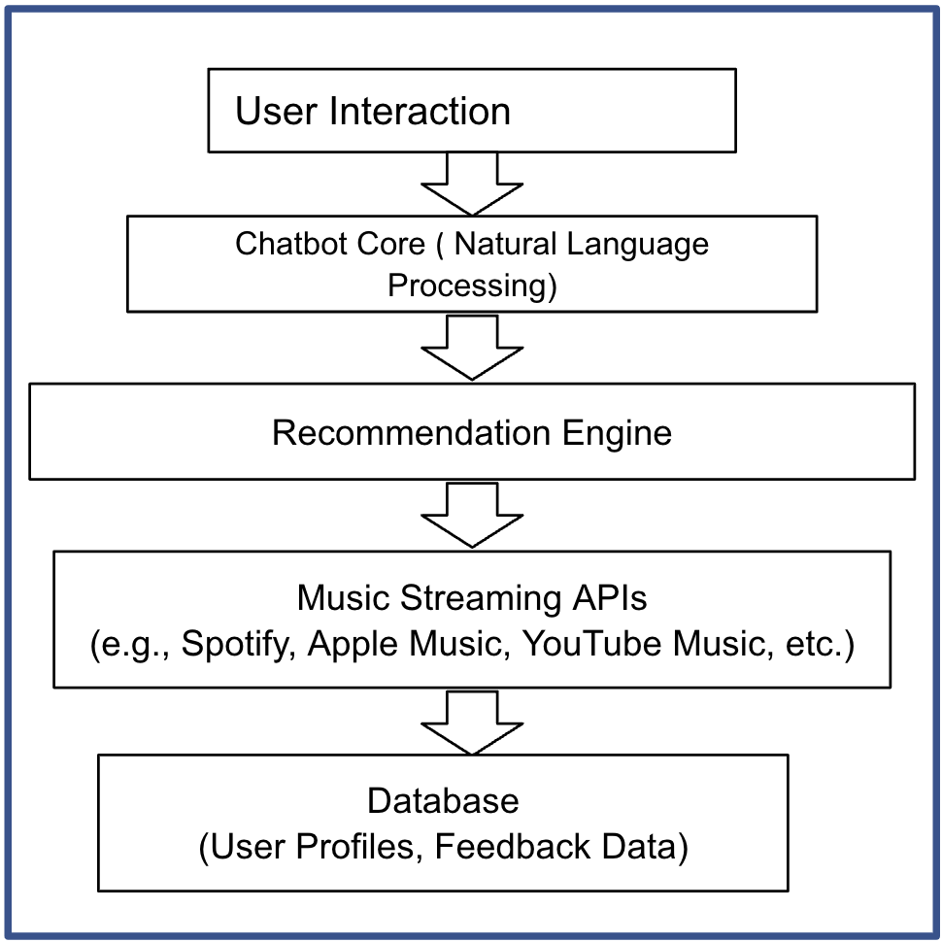

**Proposed Algorithm**

**Chatbot interface**: The chatbot interface is the interface that users interact with to ask the chatbot questions about their musical preferences.

**Song recommendation algorithm**: The song recommendation algorithm is responsible for generating a list of song recommendations for the user based on their preferences

**Recommendation engine**: The recommendation engine uses the song recommendation algorithm.

Chatbot Based on Song Recommendation

**Resource Requirement Software Requirements:**

* Operating System

a) Windows

* Coding Language

a) Python

b) HTML

c) CSS

* IDE

>>THONY

>>Pythonanywhere

* MODULES

>>flask

>>pytz

Chatbot based on song recommendation

**CHAPTER 6:RESULTS AND APPLICATIONS**

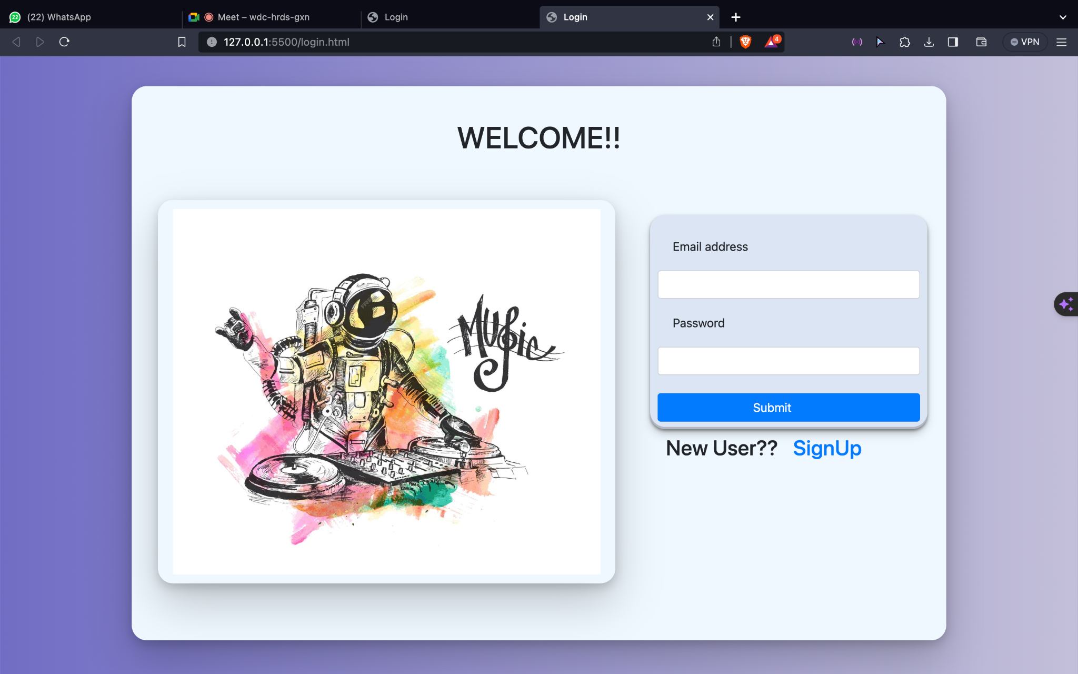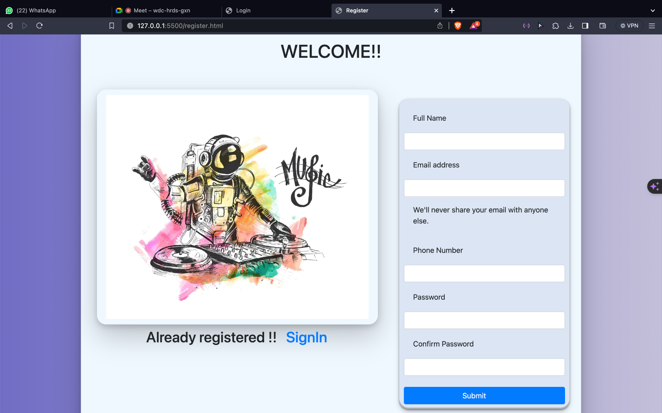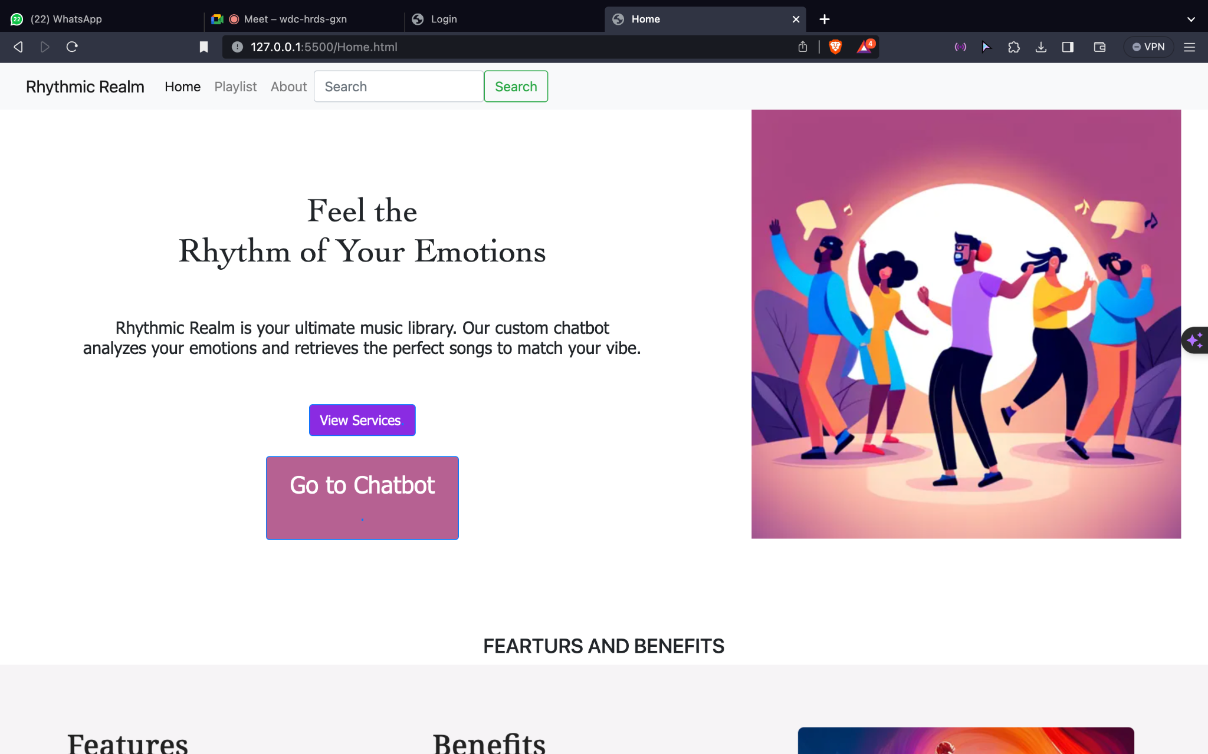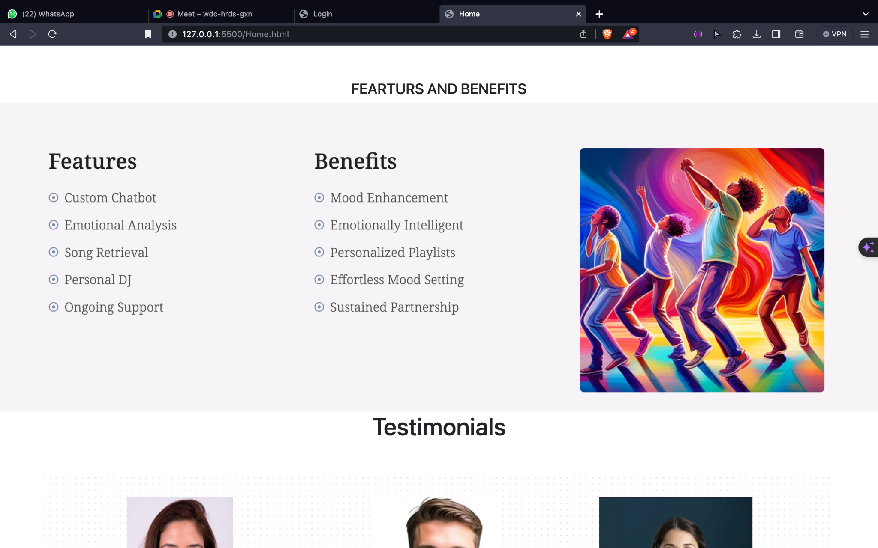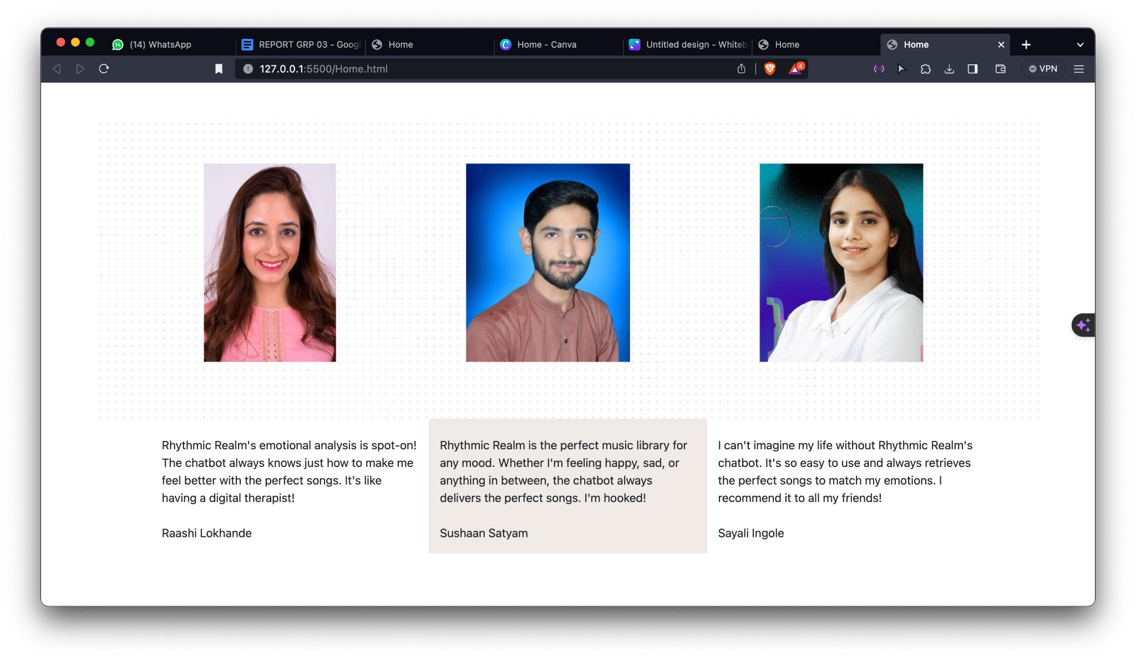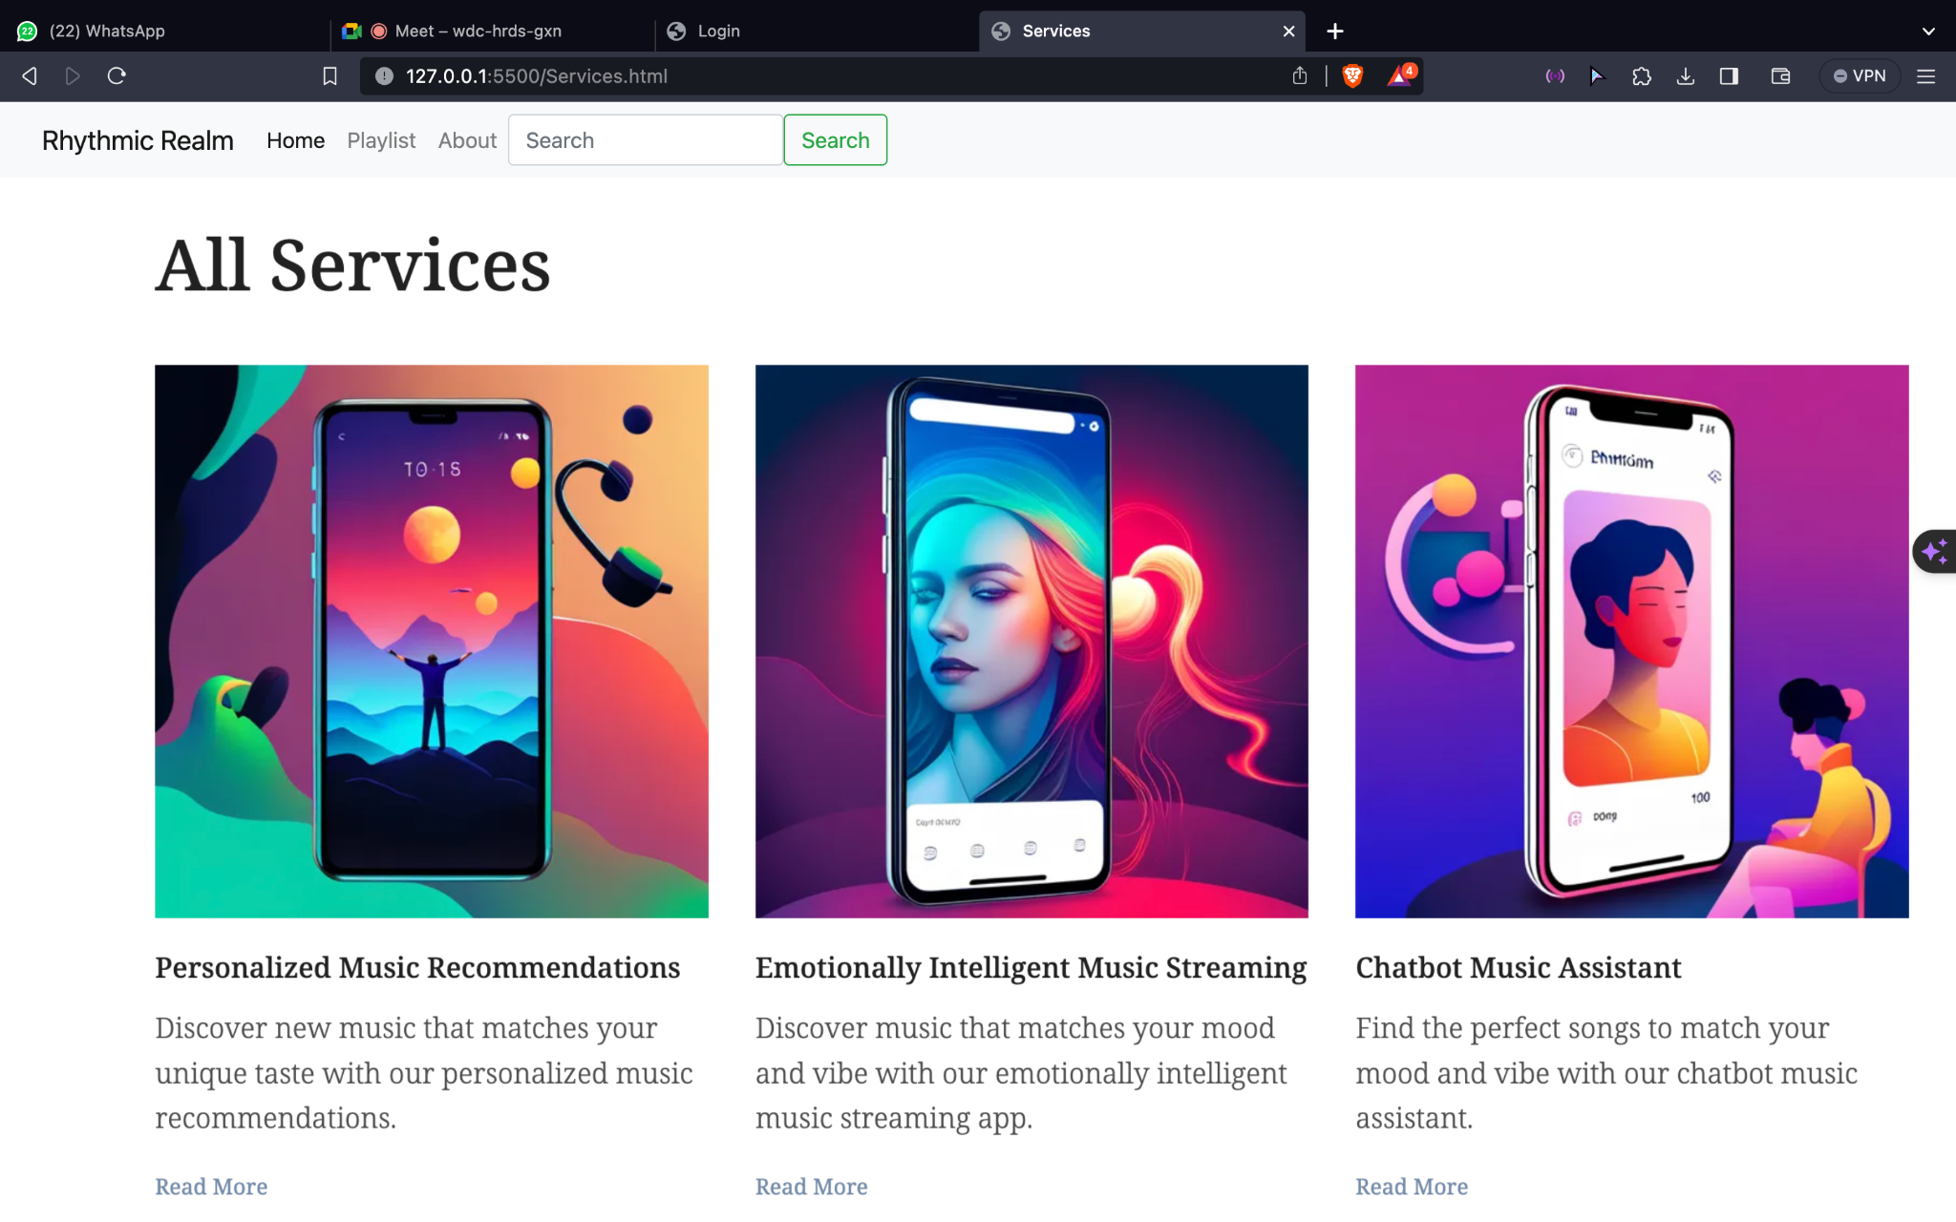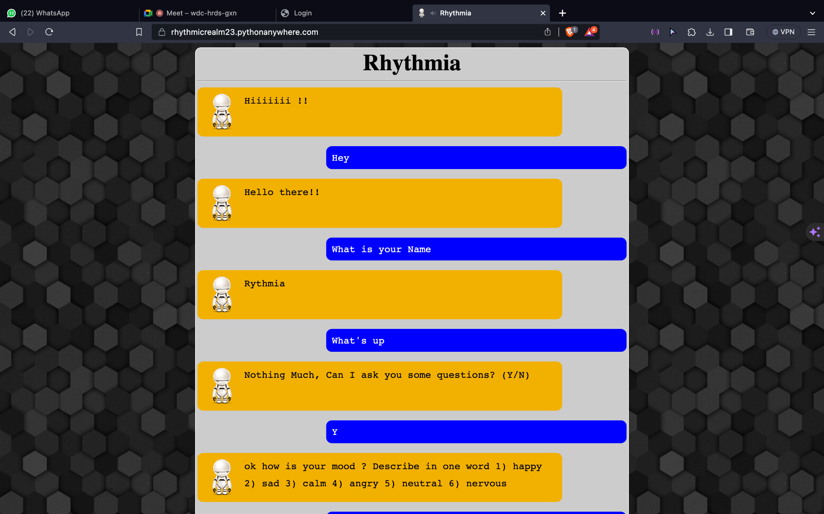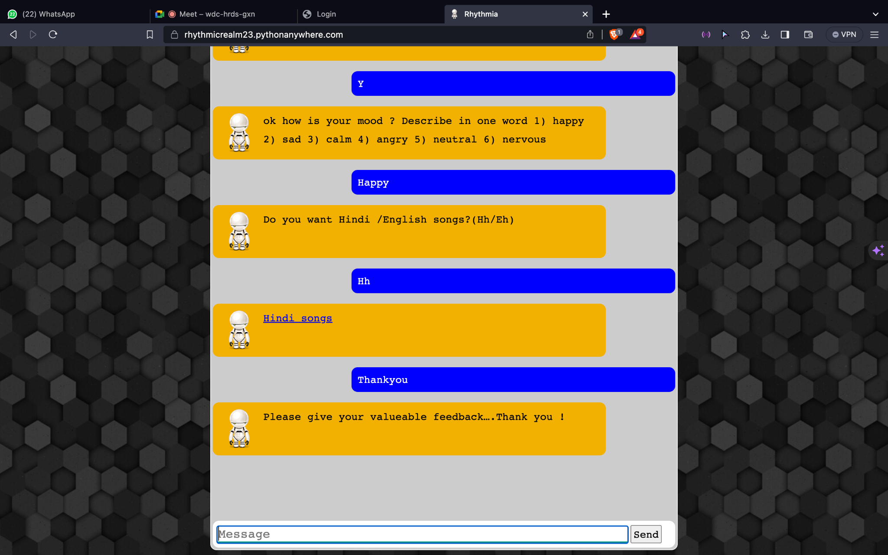

**APPLICATIONS**

* Convenience: Chatbots are always available, so users can get song recommendations whenever they need them.
* Personalization: Chatbots can generate personalized recommendations based on the user's individual music taste and preferences.
* Discovery: Chatbots can help users discover new music that they may not have found on their own.
* Variety: Chatbots can recommend songs from a wide variety of genres and eras.

Chatbot based on song recommendation

**CHAPTER 7:CONCLUSION & FUTURE SCOPE**

Chatbot-based song recommendation systems have the potential to revolutionize the way that people listen to music. By providing users with personalized and interactive song recommendations, chatbot-based systems can help users to discover new music, save time, and have a more enjoyable listening experience.

Chatbot-based song recommendation systems are still under development, but they have already shown great promise. In the future, we can expect to see these systems become more sophisticated and widely adopted.

**FUTURE SCOPE**

* More accurate and personalized recommendations: Chatbots will be able to generate more accurate and personalized recommendations as they learn more about the user's music taste and preferences over time.
* Better music discovery: Chatbots will be able to help users discover new music that they are likely to enjoy, even if it is from a genre or era that they are not familiar with.
* More natural and engaging user experience: Chatbots will become more natural and engaging to interact with, making it easier and more enjoyable for users to discover new music.
* If Integration with other AI technologies: Chatbots will be integrated with other AI technologies, such as mood detection and music generation, to create even more personalized and engaging music experiences.

**REFERENCES**

1. Python for Chatbot Development by Real Python
2. Smith, J. (2020). The Role of Personalized Music Recommendations in Enhancing Music Enjoyment. Music Science Journal, 5(2), 87-101.
3. Brown, A. (2019). Improving Music Discovery with Recommendation Systems. Journal of Music Technology, 12(1), 45-58.
4. Johnson, M. (2018). Mood Detection in Music: Challenges and Solutions. International Conference on Music and Technology, Proceedings, 112-125.
5. Davis, S., & Wilson, P. (2017). The Impact of Personalization on Music Consumption. Music Experience Symposium, 25-34.
6. White, L., & Parker, R. (2016). A User-Centric Approach to Music Recommendation Systems. Journal of Personalized Music, 3(3), 165-178.

Chatbot based on song recommendation